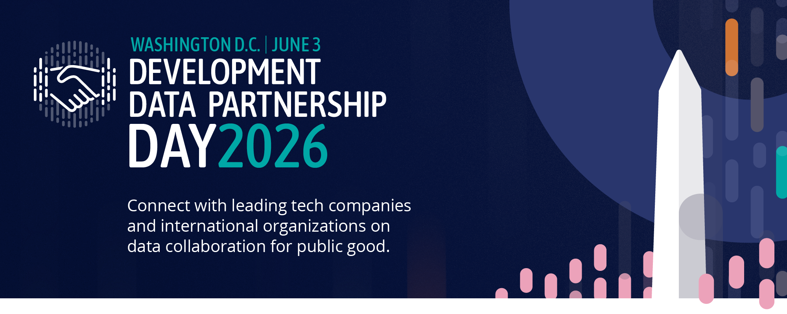

DEVELOPMENT DATA PARTNERSHIP DAY

Time | Topic | Lead
8:30 | Registration
9:00 | Opening Remarks
9:05 | Keynote Address | Dr. Aisha Walcott-Bryant, Head of Google Research Africa
9:25 | State of the Partnership | Holly Krambeck, Program Manager, World Bank
9:35 | How AI is Reshaping Labor Markets: Findings from International Organizations Working with LinkedIn Data  Economists from the OECD, IMF, World Bank, and CAF share what LinkedIn's global data is revealing about how AI is reshaping skills, hiring, and labor markets — moderated by LinkedIn | Casey Weston, Senior Manager, LinkedIn (Moderator)  ---  El Iza Mohamedou, Head of the OECD Centre for Skills, OECD  Cheryl Li, Research Analyst, IMF  Sahiti Sarva, Data Scientist, World Bank Group
10:25 | Impact Stories  Fast-paced relay-style presentations, jointly given by the tech company and the international organization staff who worked together to create impact. | Connecting Guatemala's Schools to the Internet  Enrique Iglesias Rodriguez, Telecomunication Sector Specialist, Inter-American Development Bank  Katherine Macdonald, Senior Director, Ookla for Good & Strategic Initiatives, Ookla  Advancing Low Emission Zones in Southeast Asia  Sebastian Muller, Technical Lead, Data & AI  Asian Development Bank
11:00 | Break
11:15 | AI's Impact on Work and the Economy: Research from the Companies Building the Technology  Researchers from Anthropic, OpenAI, Microsoft, and Google share what their in-housework is revealing about AI's effects on jobs, productivity, and economic opportunity — in conversation with the World Bank Group Chief Economist | Indermit Gill, Chief Economist, World Bank Group World Bank (Moderator)  ---  Ruth Appel, Economics Program Manager, Anthropic  Rachel Brown, Data Scientist, OpenAI  Seth Spielman, Director, Microsoft AI  Michael Pisa, Economic Opportunity Lead, Google
12:15 | Impact Stories  Fast-paced relay-style presentations, jointly given by the tech company and the international organization staff who worked together to create impact. | Integrating Flood Risk with High-resolution Wealth Mapping in Asia and the Pacific  Takaaki Masaki, Senior Economist, Asian Development Bank  Mapping Human Displacement in Sub-Saharan Africa Using Nighttime Lights and Meta data  Mohamed Ali Hadj Taieb, African Development Bank
12:50 | Closing Remarks
1:00 | Close

